Welcome home
The next few years rolled on in a contented buzz. Like other newlyweds we worked on how we make decisions, sex, money, and work-life balance. We probably didn’t get everything (Maybe anything?) right on the first try, but we were making progress and life was good, and marriage was a terrific improvement. Being in a good relationship doesn’t mean constantly staying together. Spending time apart can build trust and keep things exciting, even reigniting sparks in a relationship.
There was an American missionary we lightly knew named Mike Mansfield who was living and working near what became the Manantali Dam project (that’s the Lake on the map below, made by damming the Bafing River). He went home, experiencing an illness which turned out to be an inoperable lung cancer. After the diagnosis, he wanted to return and pack up sell off, and terminate his ministry in the area. There was no one from his mission, family or friends to help him. Our team discussed this and we decided that Ben Chin and I would go help him.
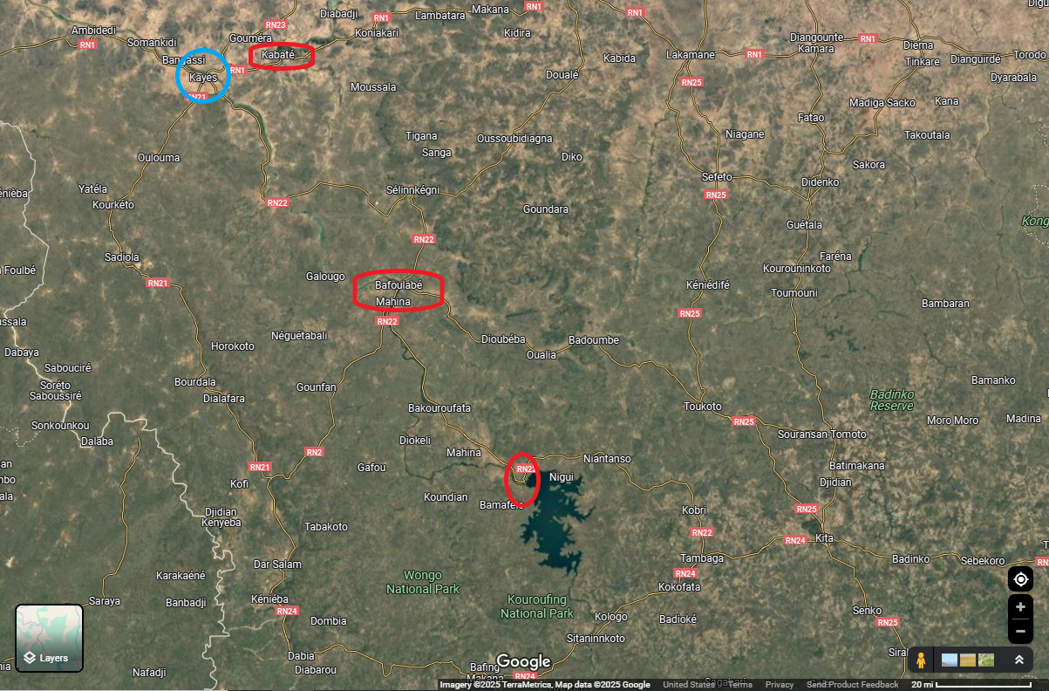
Our village of Kouroukoula is located in the upper red marked area roughly 120 miles NNW of his location. There was a dirt road from near our village to Kayes (blue circle) and a train that went from Kayes to Bafloube (middle red circle). That was also the only place one could cross the river without swimming. There were no roads worthy of the label in between us.
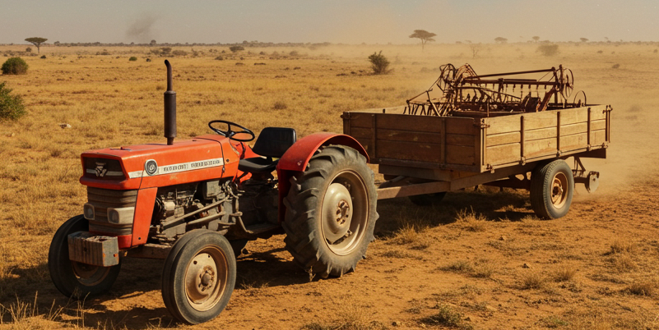
This is not the story of our adventures getting there or while helping him. While we were there we were in once-a-day radio contact with Cathy and our team in Kouroukoula. One thing Mike needed to do was get rid of his diesel Massey Ferguson tractor and trailer and agricultural implements. For a modest price we bought them and inherited the adventures of getting them back to Kouroukoula. That took a week of bush work, during which time we were out of communication.
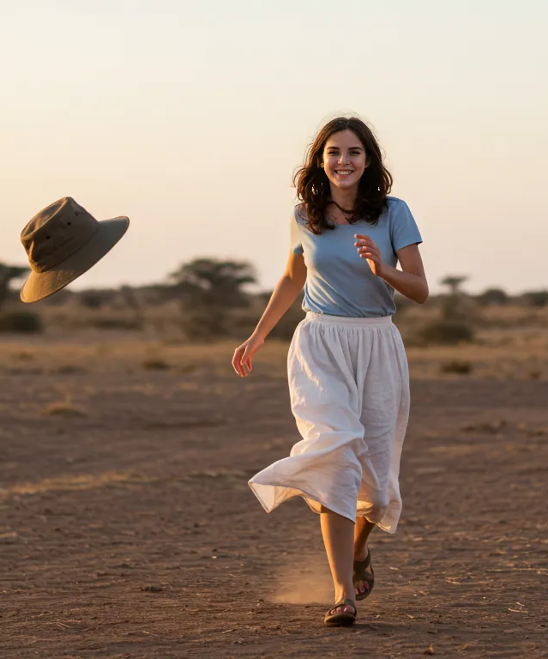
The diesel engine of the tractor was able to be heard well before our arrival so our students and staff began to gather and shout a welcome. One person ran past them and could be heard above the rest. I threw my hat at her.
The look on her face was fierce and loving in an indescribable way. I stopped the tractor and ran to her. She dragged me into the house where we rapidly showered together. That night the moans and howls weren’t all coming from the African bush.

