The ordinary becomes thrilling
Over the next year and a half or so, our relationship deepened. We did some things that might conventionally be thought of as dates, but they weren’t the usual conventional things. We did some repeats of the lobster on the beach, went for walks, and were always talking and listening to each other. We never did a “movie and dinner” kind of date. That just didn’t seem relational and connecting to me nor to Cathy of those days.
Much of what we did was to “do life together” things. We did our grocery shopping together.
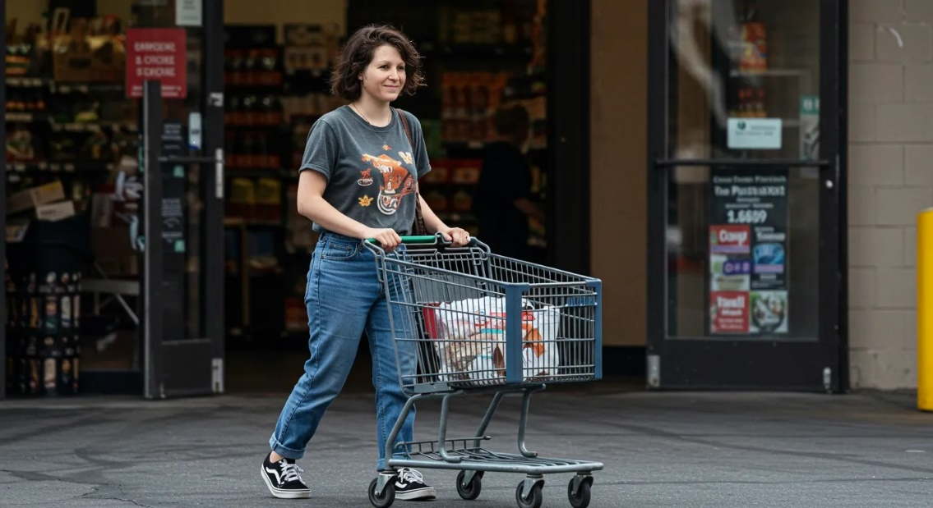
When you recognize the small things, even chores feel like a team effort, bringing you closer daily. We worked on cars (ours and others) and welding. We went to church and singing together added to the joy. As that Bible study leader I mentioned in a prequel, I spent a lot of time prepping, and now I spent it prepping with Cathy. Typing was much more fun when she was on my lap and my arms were wrapped around her. Doing life together infused the ordinary with endorphins and oxytocin that made the ordinary thrilling. Folks started seeing us as a case of static cling.
I found that this relationship with Cathy made me more creative and energetic in my work at the shipyard and in my activities at church and in thinking about my African future.
A solid bond isn’t the result of luck or finding someone flawless—it’s built step by step. The little things matter more than big, flashy gestures. A quick laugh together, a kind word, or simply showing up can mean more than any grand act. Those simple acts build something real over time. Love lasts when care and commitment become a daily choice.
One time I remember us driving in my Pinto and Cathy went quiet. I often felt in synch with her thoughts and asked her what she was thinking. When she said “oh nothing really” I said that I thought she was thinking about what life would be like if we were married. Since I was thinking about that too, how about if we do it out loud so that we can make wise decisions when the time came. She agreed that she had been thinking along those lines and that we could and should talk about it.
We envisioned our future as something we were building together. We talked openly about our practical goals and the dreams we wanted to achieve.
About 4 months into this relationship, I was ready to tell my family about it. I was living in California, they were in Grand Rapids Michigan, and I was coming home for Thanksgiving. I was wondering how to bring it up when my mother just asked me about it, something subtle like “Are you going to tell us about your girlfriend?” I gladly told her and my father all about her but was curious how they guessed. Afterall, girlfriends had not been much of a part of my life to that point. My mother said I walked differently.
Life and our relationship continued. The elephant in the room was the fact that I intended in the somewhat near future to move to Mali, West Africa and live in the bush as an engineer-missionary-NGO guy. I had been there before and had some idea what I was heading for. I felt like if I asked her to marry me, Cathy would say yes. I felt like she might even mean that with all her heart but have no idea what that might entail. We would live among the poorest people on the planet, in one of the hotter places on the planet, and be closely connected to a radically different African Muslim culture. I could not ask her to marry me under those circumstances.
The plan we evolved was that I would go to Mali ahead of her, with no strings or commitments from her. I even explicitly told her that I would understand if she found someone else in the mean time that I would understand. When the situation was ready, I would ask her to come and she could see the realities for herself and then I could ask her to marry me.
One thing we did in the meantime was take a marriage prep class through our church, Long Beach Grace Brethren. There was a workbook, a counsel couple, and a group of soon to be marrieds. The leader of the class commented that he had been doing this for 15 years and never met a more thoroughly prepared couple.

