The Interregnum
In June of 1984, I left for Mali with 2 friends and co-workers, Cliff Bonzo and Paul Abbot. Later, my father joined us, coming for 4-5 months each year. What happened during the next year plus in Mali is not immediately germane to the story I am telling but as in the prequels, may provide some background.
We established a legal entity known as CEFAIKO (a French acronym) as the Malian side of our American 503(c) organization known as Cornerstone Enterprises. We took up residence in the village of Kouroukoula, in the northwest of Mali, about 30 km east of the city of Kayes.
We each became adopted sons in polygamous Muslim families, learning Khassonke and Soninke languages and culture. As sons in the family, we worked in the fields and ate with the family, and slept in huts they provided (though the goat pen turned out to be cooler and nicer). We established a school, CEFAIKO teaching village appropriate skills (Carpentry, mechanics, health worker, and agricultural services) so that our students could establish their own village-based businesses. We also made literacy in mother tongue and gardening part of the curriculum. Over the next 10 years we taught 250 students, and at last count (2022) 249 were still in business.
It was physically rugged, with malaria and dysentery hitting us often and parasites taking up residence. At one point a gas cylinder exploded on and over me burning a lot of my body. Cathy and I communicated by letter (4-6 weeks one way trip) and I wore out her letters reading and reading them with sweating fingers.
Over time we figured out how to improve our conditions and survive better. I was named Cheickna Sissokho. The Sissokho clan has a totem animal the West African monitor lizard, and also most commonly marries into the Socliba clan. I talked with my African family about Cathy coming, and they worked out where she should stay and that her name would be Hawa Socliba. (Hawa means Eve).
In the fall of 1985 (cool dry season in Mali) things seemed as ready as they were going to be and I asked Cathy to come. When I got her flight information, I left the bush and came by train (which could be pretty rugged) to the capital Bamako. As I moved towards the somewhat civilized world, I began trying to see things through the eyes of this delightful woman who spoke no French and had travelled very little even in the US. I particularly feared for the unspeakable chaos of her initial arrival right at the airport. The overwhelming noise, smell, crowds pushing with packed bodies, rampant thievery, well I had to be there to get her through that. I couldn’t have her go through that alone.
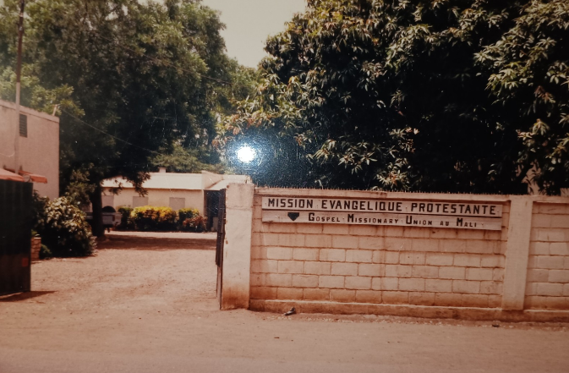
On the appointed day, I checked with the airline and got the arrival time. It was Sabeena, at the time, the most reliable service to Mali. I arranged for a taxi to take me there (the airport was 18 miles out of town), I had a place for her in the GMU guesthouse and everything I could think of was taken care of. I relaxed in my own room at the GMU- luxury, it had a bed, clean sheets and a fan.
I was stirred in my revery by a knock at the door. Sabeena called the GMU and told me that the arrival was hours early and would be landing in a half an hour. My plans falling apart, I ran out of the guesthouse looking for a taxi. There was nothing, not even much car traffic let alone a taxi. I kept running and hoped I could hitchhike. No luck.
Folks of European descent were known as toubabs and they seldom walked anywhere. The sight of a toubab running must have been really bizarre. It was strange enough, that a bus stopped and asked me what was wrong.
There was no regular bus service as you might think of it. This was a bus for the female employees of a government factory. I think it was the matches factory. I briefly told them my soon to be fiancée was arriving at the airport in just a few minutes instead of its usual time and I was trying to get there to help her through the arrival chaos.
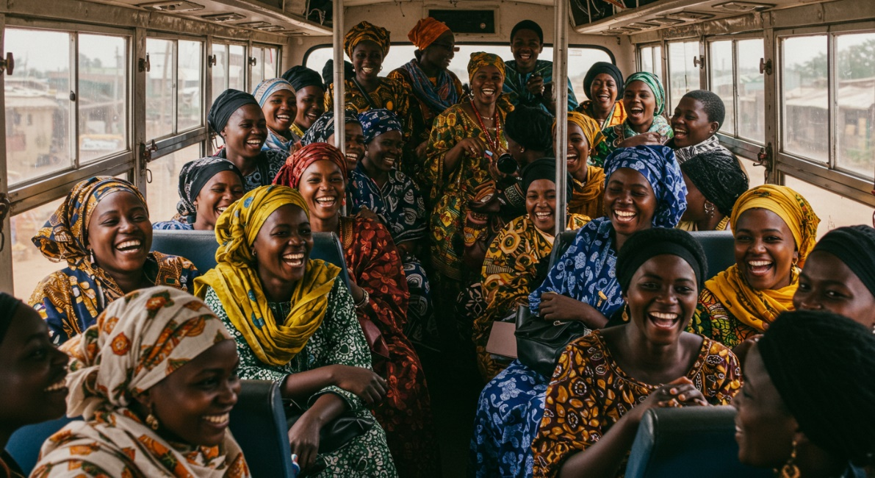
The women shouted to the bus driver that this was a romance like a TV show. When he protested, they shouted him down and got him to floor it to the airport. Along the way, they asked me all about Cathy.
At the airport, the bus pulled up at a barricade manned by soldiers who said I couldn’t proceed. The women poured out of the bus and shouted down the soldiers, walking over past, over and through the barrier. We came to another and once again the soldiers said we couldn’t go further but the women would not be held back. They stayed with me till Cathy was in my arms and shouted at the various officials to not make any problems. They didn’t.

