Meeting Cathy

Verse 1
I walked into what they called a prayer meeting,
but it felt more like a gentle little scheme.
Cookie, Judy, Myron grinning,
six young women in the room —
and me the extra puzzle piece in someone else’s dream.
We played Uno round the table,
colors flashing, laughter light,
and across from me I saw her —
small in stature,
but something in her spirit
shone bright.

Verse 2
The chairs kept shifting,
and somehow she landed right beside me,
quiet as a question I didn’t know to ask.
I didn’t know much Uno,
but I learned I could lose on purpose,
tilt the game her way
with a kindness she returned back.
I might’ve forgotten her name by morning
if not for what came next —
a green Corolla coughing in the dark,
a sheepish nod,
a gas gauge sinking past regret.

Chorus (Anthem)
Static cling and sky rockets,
every life begins in pockets —
tiny sparks in quiet places
shaping all we’re meant to be.
Static cling and sky rockets,
ordinary turns to promise —
and the smallest, shy beginnings
whisper of what might yet be.

Verse 3
My Pinto held the tools I needed,
and she stood watching while I siphoned fuel,
her breath a little cloud in the night air.
A couple gallons, a grinding starter,
and suddenly her engine woke —
she smiled, said goodbye,
and somehow I was holding
her number written there.
Over weeks we talked like pilgrims,
her voice steady, searching, brave,
and I listened as she carried
more weight than someone her age
should have to bear.

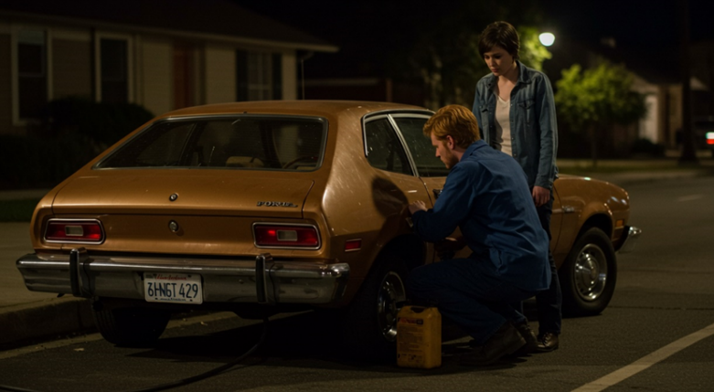Verse 4
Then came the job she wouldn’t take —
something wrong beneath the offer,
something she refused to compromise.
“I’ve decided there’s no room for sin,”
she said with fire in her eyes,
and those words carved themselves
into the soft wood of my memory.
Days later God provided,
and she praised Him like the dawn,
and something in her courage
kept me quietly holding on.
I didn’t know what it meant yet,
or what the future had in store —
just a girl with fire in her spirit,
and me wanting to know her more.

Bridge (Anticipation)
So I asked her to the shoreline,
hot chocolate warming both our hands,
waves whispering secrets to the sand.
I didn’t know her story yet,
or what the night was leading to —
just a short girl in the fading light,
and something in me
leaning gently toward the new.

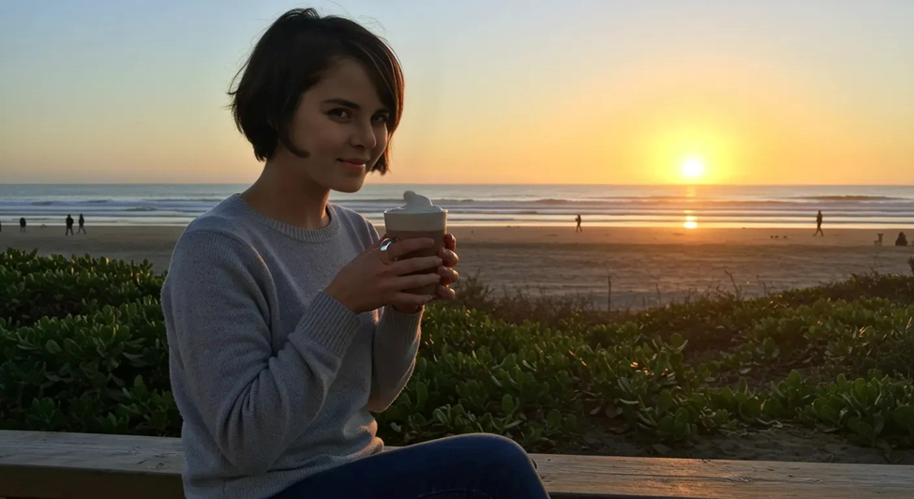Final Chorus Anthem
Static cling and sky rockets,
every life begins in pockets —
tiny sparks in quiet places
shaping all we’re meant to be.
Static cling and sky rockets,
ordinary turns to promise —
and the smallest, shy beginnings
whisper of what might yet be.

