Favorite Date
I can’t give the timing of this date with absolute certainty, but I am sure that fairly soon after hot chocolate on the (sandy) beach came my favorite date. I am fairly sure I did it multiple times. It was lobster on the (rocky) beach.
Both my Coast Guard time, and my shipyard time had me around the working waterfront fairly often. It was there that I met a lobsterman who took a shine to me and felt a need to make his contribution to my not-romantic-enough life. He provided me with abundant lobster tails on condition that I use them on dates. I saw no reason to refuse his help!
San Pedro California was just a few miles from Long Beach and part of it was very rocky with almost cliffs near the shore. A friend showed me a place where you could park and get down the cliffs on a walkable trail that was probably less than a quarter mile. Once down there, the cliffs cut you off from everything but the sun, wind and ocean. The beaches were rocky and devoid of most humans and it became an ideal date place for me.
I took Cathy there, eager to share with her this spot and lobster. I packed everything needed in a backpack and we hiked down to it. We quickly gathered driftwood for a fire and got it started. The lobster tails were wrapped in aluminum foil with butter and lemon and put in the coals. I then oiled up a wok and cooked up veggies and rice over the fire. We drank sparkling apple or grape juice from goblets while it cooked and then ate from China plates (from Goodwill!) as the sun set.
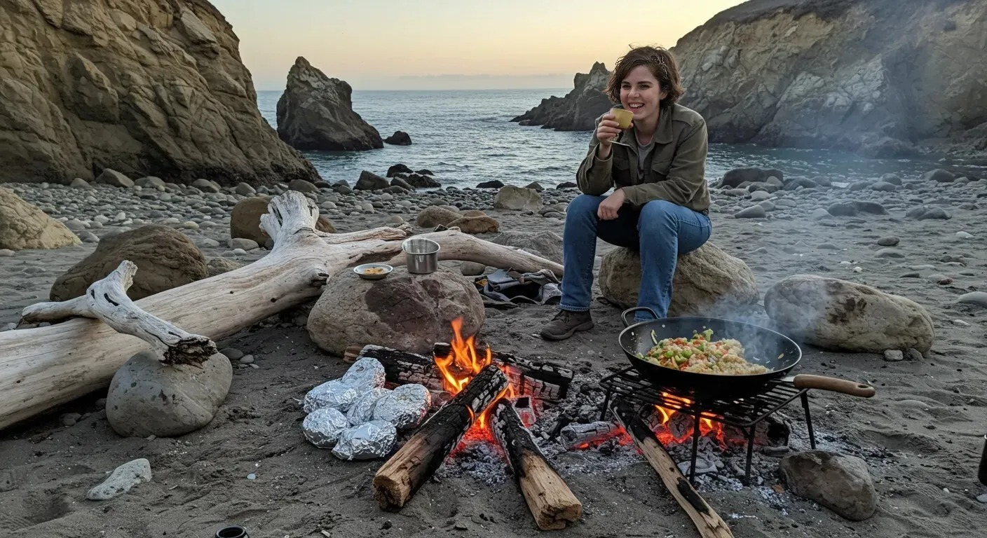
It was wonderful to have her to myself with no distractions and to get to know this fascinating woman.

