First Kiss Story
Well, this was new territory for me. If you count the hot chocolate on the bench and the lobster on the beach, I’ve had 2 dates with the same woman. We also had lots of phone calls even before I asked her out. I was really liking her and she seemed OK with that.
I remember Cathy coming over one day to work on her car. She seemed to really like learning and doing “guy things” like mechanical things on her car. Later I taught her to weld with a small 120v AC buzz box and she got better at it then me.
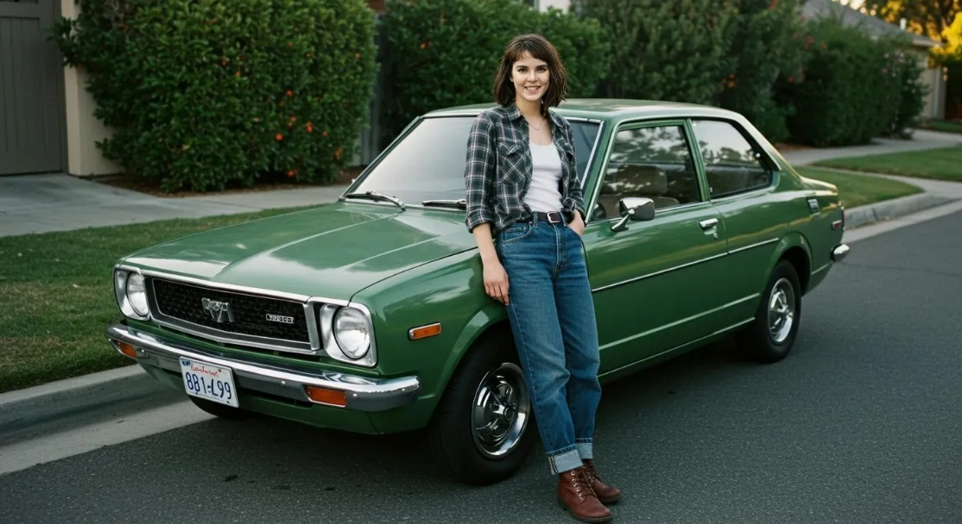
I found her eagerness, competence and confidence to be quite alluring.
One Saturday after working on her car I remember she went in to my 2nd floor apartment to wash up while I put away the tools and cleaned up outside. Done with clean-ups outside, I went to the base of the stairs and saw Cathy coming down….
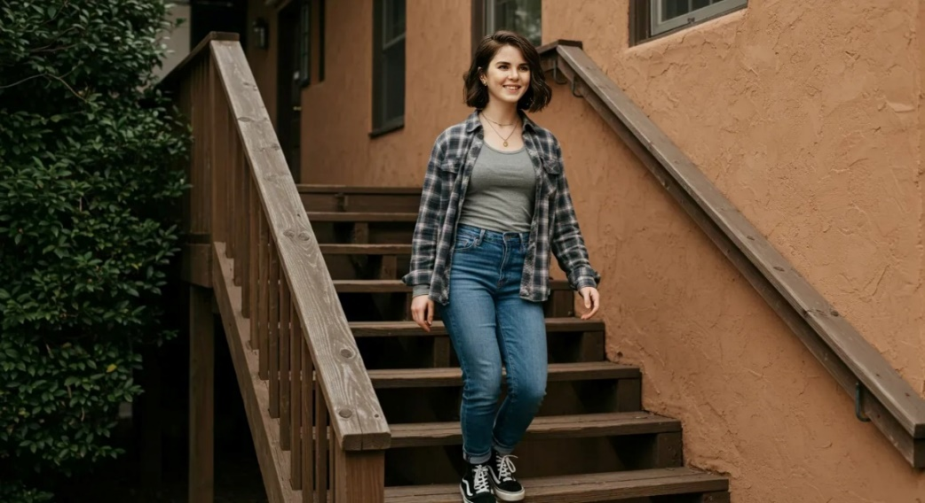
To my complete surprise, coming down the stairs, she kissed me on the forehead. In shock I said “A little lower please” and she kissed me on the lips. Skyrockets!
Over the next year and some, Cathy introduced me to a new contact sport-kissing. I had no idea what endorphins and oxytocin could be unleashed by lips in contact with skin. We kissed often and long, whenever and wherever we could. I remember one night we were kissing in my Pinto, parked on a quiet street with our windows fogged up. A policeman knocked on our windows…we hadn’t noticed the rotating red light… greeted me by name…. and told us we needed to move along.
Our clothes stayed on and hands stayed in public places. To some that may sound constrained and boring, but I can personally assure you I found it exciting and sexy. If that seems hard to believe, review some movies done under the Hayes Code. I think Jimmy Stewart could make very powerful sexy themes without needing to show skin or talk dirty.
Somehow in all this, Cathy figured out that I was not gay,

Sky Rockets and Static Cling

A Poem from the First Kiss
Before I knew the shape of her yes,
before welding arcs and phone-line laughter
braided our days together,
I only knew this:
I liked her,
and she didn’t seem to mind.
She came over to fix her car—
hands eager, learning fast,
grease smudged like war paint
on a woman who could out-weld me
before she ever out-loved me.
Competence has a way of undoing a man
more quickly than perfume.
That Saturday, she climbed my stairs
to wash the day from her hands.
I stayed below, putting tools to rest,
heart already restless enough.
Then—
footsteps on the steps,
light as a decision already made.
She leaned in,
kissed my forehead
like it was the most natural thing in the world.
I, stunned and foolishly brave, whispered,
“A little lower, please.”
And she did.
And the sky cracked open.
And something in me
finally believed in fireworks.
After that, she taught me
a new kind of contact sport—
kissing as if the world were made of oxygen
and we were learning to breathe.
Windows fogged,
Pinto rocking gently with laughter,
a policeman tapping the glass
while we floated somewhere
far above the curb.
We kept our clothes on,
kept our hands where decency could see them,
but desire doesn’t need shortcuts
to be holy or thrilling.
Jimmy Stewart could’ve filmed us
and still blushed.
And somewhere in all that
soft collision of lips and wonder,
Cathy figured out
I wasn’t gay—
just waiting for the right woman
to knock the truth loose
with a kiss.

Sky Rockets and Static Cling

A Lyrical Poem from the First Kiss

Before love had a name between us,
before sparks leapt from phone lines
and the smell of warm metal
followed her into my days,
I only knew this:
her presence rearranged the air.
She came to fix her car—
curious hands, fearless hands,
hands that learned the language of tools
as if she’d been waiting for the chance.
Grease on her cheek,
sun in her hair,
and something in me quietly
coming undone.
Later she would out-weld me,
steady as a hymn,
but that day she simply climbed my stairs
to wash the dust from her fingers
while I put the world back in order
one tool at a time.
Then—
footsteps descending,
soft as a promise.
She leaned in,
kissed my forehead
like she was touching a thought
I hadn’t spoken yet.
I whispered,
“A little lower, please.”
And she answered
with a kiss that cracked the sky open,
a kiss that rewired the stars,
a kiss that made my knees
forget their job entirely.

After that,
she taught me the art of collision—
lips finding lips
like flint finding steel,
heat blooming in the quiet places
where breath becomes prayer.
We fogged the windows of my Pinto
until the night disappeared,
a policeman tapping the glass
while we floated somewhere
far above the curb,
far above everything.
We kept our clothes on,
kept our hands honest,
but desire doesn’t need shortcuts
to be thunderous.
Some loves burn clean
and still light the whole horizon.
And somewhere in all that
holy mischief of lips and laughter,
Cathy realized
I wasn’t gay—
just waiting for the woman
whose kiss could wake
the sleeping fireworks in me.

Sky Rockets and Static Cling

A Love Song from the First Kiss

Verse 1
Before love had a name between us,
before sparks leapt down the telephone line,
you came over just to fix your car,
hands steady, curious, shining like a sign.
Grease on your cheek, sun in your hair,
and something in me quietly giving way.
You climbed my stairs to wash the dust off,
and I waited at the bottom, not knowing what you’d say.

Chorus
Sky rockets, static cling,
one soft kiss changed everything.
A little lower, and the world took wing—
oh Cathy, you rewired my heart that spring.
Sky rockets, static cling,
who knew love could start with a simple thing?
Just a kiss on the stairs,
and the whole night began to sing.

Verse 2
You kissed my forehead like it was nothing,
like you’d done it a thousand times before.
I whispered, “A little lower, please,”
and your lips found mine,
and the sky found its roar.
You taught me the art of gentle collision,
lips like flint striking fire in the dark.
We fogged up the windows of my Pinto laughing,
never noticed the red light or the cop in the park.

Chorus
Sky rockets, static cling,
one soft kiss changed everything.
A little lower, and the world took wing—
oh Cathy, you rewired my heart that spring.
Sky rockets, static cling,
who knew love could start with a simple thing?
Just a kiss on the stairs,
and the whole night began to sing.

Bridge
We kept our clothes on,
kept our hands honest,
but desire doesn’t need shortcuts to burn.
Some loves are clean,
some loves are thunder,
some loves teach a man how his heart can turn.
And somewhere between the laughter and breathing,
you figured out something true about me—
I wasn’t confused,
just waiting for the woman
whose kiss would set all my fireworks free.

Chorus (final)
Sky rockets, static cling,
one soft kiss changed everything.
A little lower, and the world took wing—
oh Cathy, you rewired my heart that spring.
Sky rockets, static cling,
who knew love could start with a simple thing?
Just a kiss on the stairs,
and the whole world began to sing.

