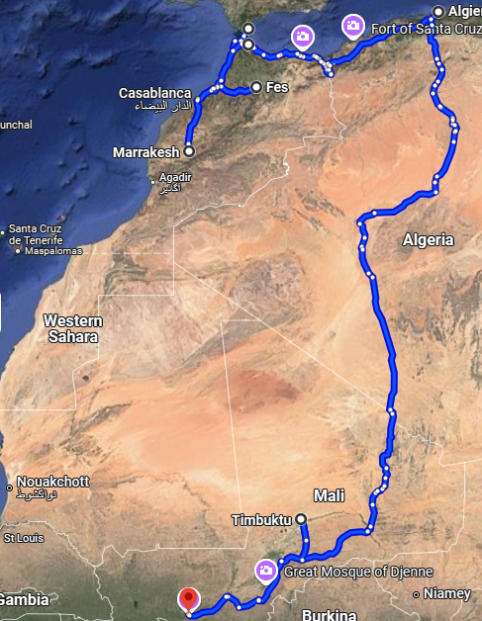
Crossing the Sahara
Geography Notes- Our trip from Gibraltar to Bamako was about 4500 miles. 1500 of those miles were roadless sand, and 1500 of it was dirt roads of the “two ruts” variety. The path Google drew here is not exactly the same but as ours, but it is now paved and there are more towns or stopping places shown the existed 40 years ago.
We entered Africa from Spain, crossing on a ferry at Gibraltar. In Morocco we distributed some items that were needed by friends but not welcomed by the government and continued south. To our dismay, we were not permitted to go further south and enter Mali by way of Mauritania. The Kingdom of Morocco was seeking to annex Spanish Sahara and the Sahraouis were not happy about it.
We were required to retrace our path back north and drive along the Mediterranean coast and then enter Algeria where we hoped on plan B to cross the central Sahara. Morocco and Algeria weren’t getting along so the Algerians made us unload everything in the Land Rover and trailer in an unshaded place, open every bag and suitcase for inspections by soldiers at a not busy border. Unfortunately, we were the most exciting thing available so no-one was anxious to get rid of the entertainment. That took nearly 2 exhausting, sunburning days.
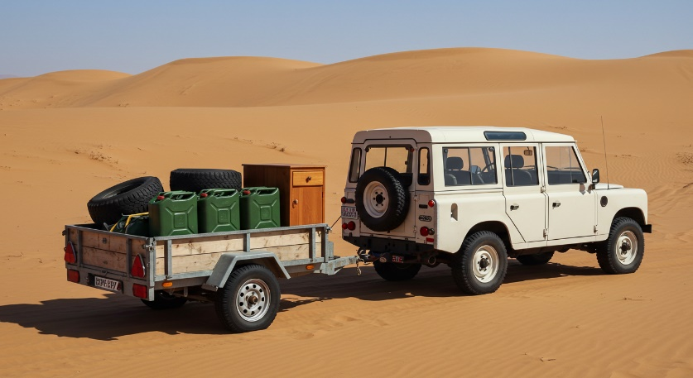
We proceeded to Algiers and then south. At the end of the paved road and the beginning of the desert sand, we took a break at the last hotel before we would undertake the Sahara. There was 1500 miles of sandy Sahara ahead but about 1000 miles in there was a place we could rest and get water and fuel. Fuel was cheap in Algeria and I had enough in the diesel containers to make it to Kayes, and water for 2 weeks. We thought we could drive 25 to 40 mph and so get to the 1000-mile mark in 2 ½ to 4 days.

As rested and prepared as we could figure, we set out. In the sand we could often see places where others had been before us. Not continuous tracks, but marks covered and uncovered by blowing sand, and when in doubt, head south. What totally slammed us were places of particularly fine sand, almost dust. We would easily sink in and 4-wheel drive couldn’t get us out. I would dig and Cathy would drive and each “stuck” could take 1-3 hours. In our first 24 hours, on our best calculation, we made only 25 miles and were completely exhausted. There was no way we could do 1500 miles like this. If we weren’t so exhausted, we would have been ashamed, but we went back to the hotel for a rest and re-think.
On the way back, we didn’t get stuck at all. After a day’s rest and rehydration, we decided if we were carefully alert, we could avoid the dust spots since they looked slightly different. We needed to be alert with calibrated eyes. We also found the hood of a Deux Cheveaux (an ugly French car) and kept it with us to help get us out when stuck.
Round 2 went much better. We couldn’t drive at night because we couldn’t distinguish the trouble spots, but by being constantly alert and careful we hardly got stuck and we started averaging 30 to 40 miles an hour. We drove as long as we could and then ate a simple meal, rehydrated and climbed into the Rover to sleep.
Daytime temperatures were ferociously hot, but when the sun went down, it got cold fast. Snuggling up felt good on many levels. The second day we got up hydrated, ate and got going.
We were making good time again, 30-40 mph when at mid-morning we found trouble. Driving on high alert, we saw a dust patch just ahead. I was driving and spun the wheel (no power steering) to avoid it. The Rover tilted sharply and almost went over, but stayed upright. The trailer flipped while staying attached to the Rover. The furniture was shattered, the Jerry cans of fuel and water went flying, and tires went rolling down the dunes.
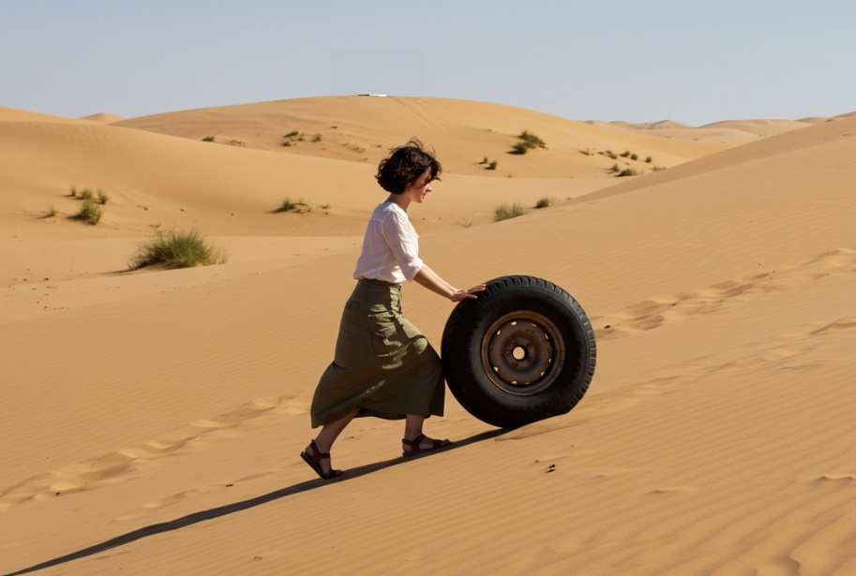
We sat in silence for a moment in the Rover, and then Cathy spoke the most loving words I could imagine. She smiled and said “I think I’ll get the tires and bring them back.” No complaints. No recriminations, no “if only’s.”
With the help of a jack, and a sledge I got the trailer untwisted, reloaded, and we got back on our way. In all those 4500 miles, she never complained. Every time I remember this, I fall in love all over again.
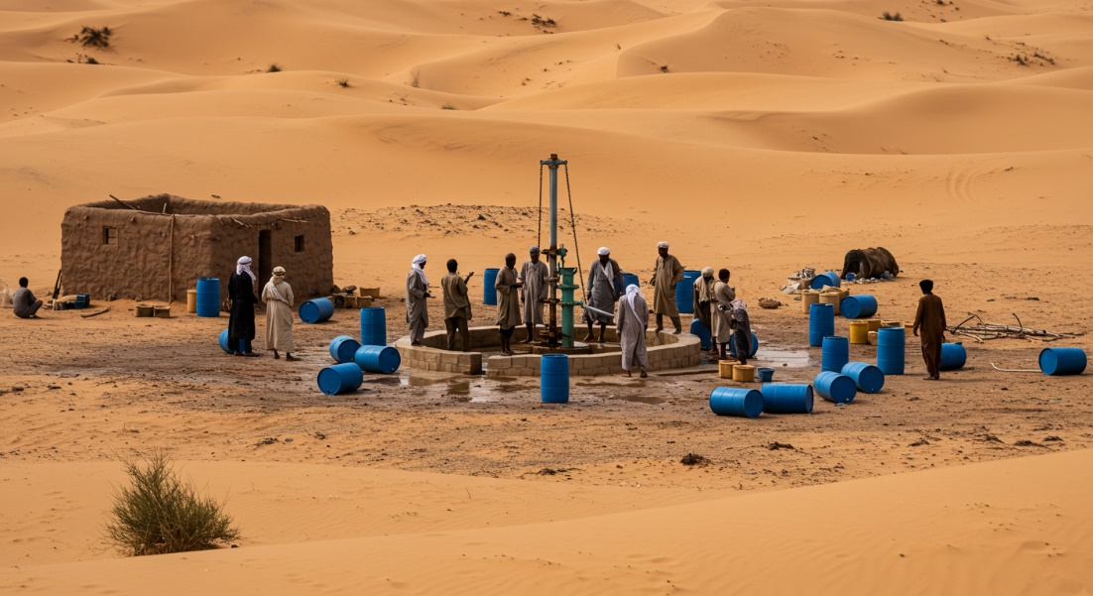
It’s not a pleasant memory, but I think I would be unfair to Cathy if I didn’t mention what happened the next day.
We came upon a surprise habitation of sorts. A borehole had been drilled and perhaps 15 or 20 men, Arabs, Berbers and Fulani were scattered about the place. They heard the roar of the Land Rover and waved us over. They invited us to have some cool water from their well. I washed my face and hands and was instantly refreshed by the evaporation. As Cathy went to do the same, I asked advice about the desert ahead. I did not see what happened next. A moment later Cathy came to me and told me that while she was getting water, a man fondled her breast.
I made the wrong response when my first words were “Is there any chance there was a misunderstanding?” Cathy was angry now with me and the man and wanted me to be a movie hero and beat up the guy (a Fulani). I saw the crew of men gathering, looking sullen, and thought we should try to leave the place alive. We made it back to the Rover and got out of there.
That evening we made it to the official outpost of the Algerian government where we could spend the night. I told the officer in charge about what happened and he said he knew exactly which man it was. The next day he told me the Fulani was dead and wouldn’t bother anybody anymore.
After all the work we put into the trailer and its contents, we lost it somewhere in Northern Mali. We drove hundreds of miles on a bone rattling, Rover rattling hardpan and during a dust storm, the trailer rattled off the hitch without us knowing where or when. We considered looking for it but the ideas of finding it seemed miniscule and worse possibilities abounded. We hope the Tuareg who would find it would find ways to benefit and we proceeded to the comparative green of Timbuctoo and Mali.

