Proposal in Kayes
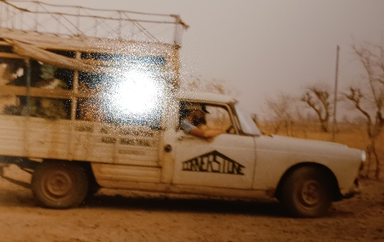
Cathy survived the airport in Bamako, got her long-term visa, and endured the train trip to Kayes. By this time, we improved our transport somewhat with the purchase of an old Peugeot 404 pickup, AKA the bachet (pron. ”Bash-ay”). For a hood ornament a desiccated toad was glued to the hood. My friends met us with the bachet so that we wouldn’t have to use any of the worse alternatives.
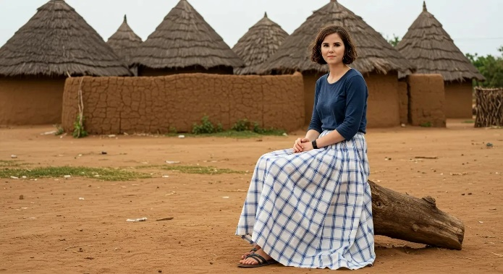
I was amazed at how quickly she adapted to village life, hanging out with the women, entertaining the children and old men. In the village, she needed to wear dresses or skirts, definitely not her preferred jeans. Village life and culture did not permit us to be the static cling when we were with them, but all the expats for 50 miles around invited us around and then we could speak English and be clingy.
There was a piece of Cathy’s past that I urged her to keep hidden, at least for now. Cathy had always been artistic, studying art, graphic design, and adjacent things. Then she paid her way through nursing school as an artist. It was the nurse part we needed her to keep secret. When there are no medical services for many miles around, a medical person can be in constant demand, and Cathy, bless her tender heart, would not know how to set boundaries she could survive.
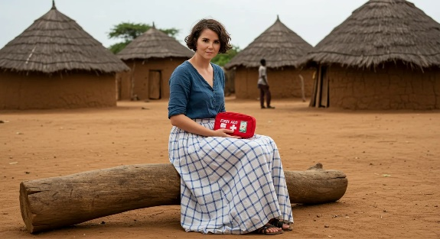
That worked for a while, but then one day, there was a little boy crying with a skinned knee. She couldn’t harden her heart and resist. She cleaned up the wound and bandaged it and immediately gained the title of “Doctor.” Everybody had medical issues and all the people and all the issues became Cathy’s.
It was a crushing load and it very nearly asked too much of Cathy.

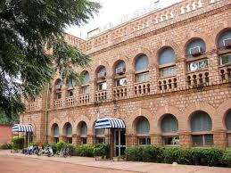
The nearest city to us was Kayes. In the French colonial times, a railroad was built that connected Dakar, Senegal (a big port on the Atlantic) through Kayes, roughly a midway point, to Bamako on the Niger River which was navigable. The French also built the Hotel du Rail at Kayes. This was the only restaurant in the western sense of the word. To the left you see a sort of cleaned up version of the hotel and restaurant. They have installed new doors and air conditioners that might work. If running water works on the second floor than pipes will burst in other parts of town.
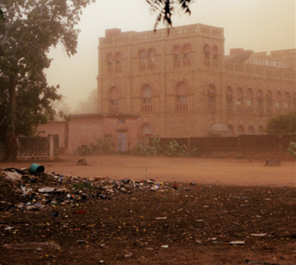
Below you can see the same building on a dusty day… could be anywhere from January till June, and the wall that tries to hold back the realities of African city life.
The manager at the Hotel was a friend I’d made named Maiga. He was a gentle giant who had befriended me when I was robbed on the train and was always looking out for me. I told him that I was going to propose to Cathy, that I had a ring. Cathy didn’t know it but she had transported the ring in her baggage when she came. Maiga did his best to have the restaurant clean and prepared for us on February 14, 1986.
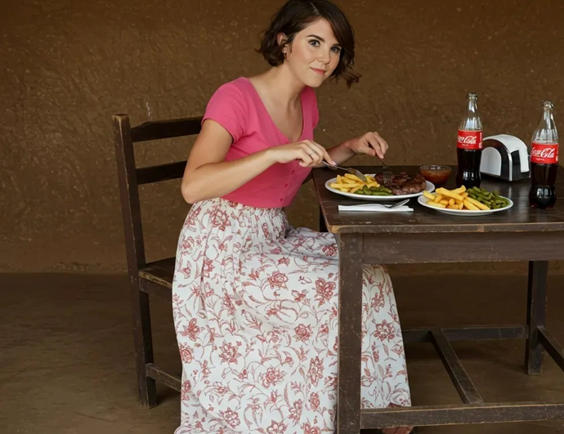
So, on Valentines Day, I took Cathy into town and we ate at the restaurant. The menu was steak, fries, and green beans with soda. After Maiga made sure that everything was as good as he could make it, he chased everyone out so no one would bother the toubabs. I was a bundle of nerves and at one point blurted out a request “Would you be interested in a name change, to Mrs. Cathy Creswell?” That might not have been an Instagram worthy proposal, but its what I could manage, and she agreed and put on my ring.
With that settled for life, I excused myself, and went out and barfed in the bushes. I just made a lifelong commitment connecting everything I am and have unreservedly to another person. I don’t know that anyone else may understand, but that was my “for better or worse” commitment made in the bushes. I meant it then and every day since.
We made plans to split up again. Cathy went back to California to plan a wedding. I stayed to build us a house outside the village of Kouroukoula by our school grounds that was becoming known as Kouroukoulundi (Little Kouroukoula). Our house had a little water tower for a gravity fed shower and sink, a small stovetop and oven that ran off bottled gas, and solar panels that provided electricity for lights, radio, and a fan. All the luxuries you can imagine. I also designed a different sort of bed, to try to have some of the “give” like a mattress, but not all the heat trapping insulation of a mattress. It was sort of like a sleeping trampoline.
I won’t spend much time describing the wedding. There are books of pictures from it. Cathy planned it well and paid for the parts that weren’t donated. Many people contributed to the wedding. Friends from church, our families, co-workers from the shipyard all came. My father sang at the wedding the old Irish song “Be thou my vision.” I was there, the pictures prove it, but I was in kind of a zombie state. I am sure the only thing I did well was kiss the bride which was something I really like doing, and I had a vague idea that I would get to do more, a lot more, soon.
Our honeymoon took place in two parts, the first few days in American hotels and then a flight to England where we spent 6 weeks. We had British friends that arranged it because they knew on the one hand, we were both Anglophiles, and on the other, they were afraid my ideas of a honeymoon would involve a mud hut. We were given a nice place to stay in Birmingham, a car was made available, and whole milk in glass bottles was delivered to our door each day.
The milk was not homogenized, so cream rose to the top. On my honeymoon I learned something that has been true for most of our married life. We were not on the same sleep schedule. Cathy thought that wherever possible, mornings were for sleeping. You don’t have to be on the same sleep schedule as your partner, but finding a rhythm that works for both of you matters. The key is respecting each other’s habits—it’s a simple way to show you care. The immediate lesson was that “The early bird gets the worm” does not apply to cream.
While we were there in England, we bought an army surplus Land Rover (heavy duty shocks made for parachute drops) and a surplus trailer. We filled the trailer with spare tires and fuel cans, and some bits of furniture for our house in Mali. The back of the Land Rover we filled just enough to level it out and put a mattress on. The plan was to cross over into France, drive through France and Spain, cross at Gibraltar, and cross the edge Sahara near the coast into Mali.
Crossing Europe seemed like an extension of our honeymoon and I still associate different cities with honeymoon memories that are well worth remembering (Paris!) but not the sort of things I will tell the rest of the world. But Barcelona! That night curled toes and steamed the wallpaper!

Of Love and Barf
This is a love story, maybe even a romance. I will take a break from the story line, to write a brief essay about love, and the way I think it can and should exist in marriage. I would like to explain, if that’s possible, why I barfed after I proposed to Cathy, and why I think that detail is not embarrassing, but is significant.
Love includes “Sky rockets and static cling.” I have been dropping comments about this up to now, and there are more to come. This part of love is always for a particular person and their particular features. Sometimes these qualities are easy to describe; sometimes they seem inarticulable. The endorphins and oxytocin are intoxicating and wonderful.
The early days of a relationship are all about the thrill—holding hands, stolen glances, and that can’t-stop-smiling kind of excitement (we all do that). But over time, marriage shifts things. The fiery passion doesn’t disappear; it just settles into something much deeper. It’s the kind of love that feels like home—the kind that doesn’t need grand gestures to prove itself.
Real love goes beyond “sky rockets” and includes actions. My least favorite philosopher is Friedrich Nietzsche who makes this point when he claims: ‘He who promises to love forever or hate forever or be forever faithful to someone is promising something that is not in his power.’ Nietzsche’s idea is that while we can predictably hope that our love will last, we cannot promise it because we can promise only voluntary actions, and love is not that. The most we can promise, Nietzsche continues, is that: for as long as I love you, I shall render unto you the actions of love; if I no longer love you, you will continue to receive the same actions from me, if from other motives.
Nietzsche limits love to the skyrockets but makes the actions of love a consequence. I would say that the Biblical view of love includes actions because (I Corinthians 13) “4 Love is patient, love is kind. It does not envy, it does not boast, it is not proud. 5 It does not dishonor others, it is not self-seeking, it is not easily angered, it keeps no record of wrongs. 6 Love does not delight in evil but rejoices with the truth. 7 It always protects, always trusts, always hopes, always perseveres.
So, love includes neurochemical feelings and concrete actions that define and describe love. Beyond that, love is an absolute, no holds barred, unconditional guarantee, commitment. When I proposed marriage to Cathy, there was an unforeseeable future to which I signed the blank check of everything I am and have, and would be and would have, and gave it to the present and future Cathy. I couldn’t foresee depression or heartbreaking times but I committed in advance to all of them (and the good times too).
This was a promise I made to Cathy, to our friends and family in our wedding, and to God. At various times Cathy, or family and/or friends, suggested that a divorce might be the thing but it was never on the table for me.
I felt the weight of that commitment when I proposed; and I barfed. I have not regretted that commitment.

